**Ntokozo Ntshangase HELP document I.T PAT**

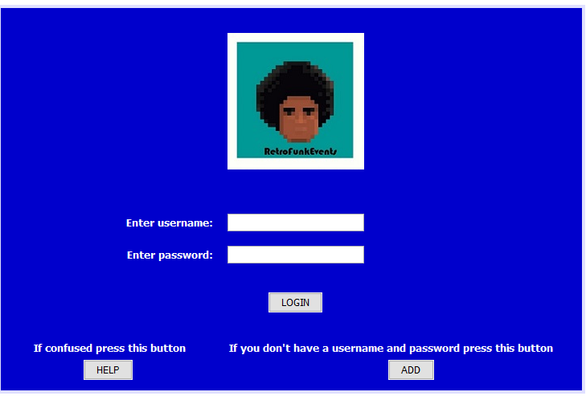 (Login panel)

Username textField: enter a username if you have one

Password textField: enter a password if you have one

Login Button: if you have an account this will check the values you entered with the textFile

Help Button: This button you pressed took you to this word document to help you understand how this works

Add button: if you don’t have a username and password just click on this button it, will take you to another page where you can add your own personal username and password

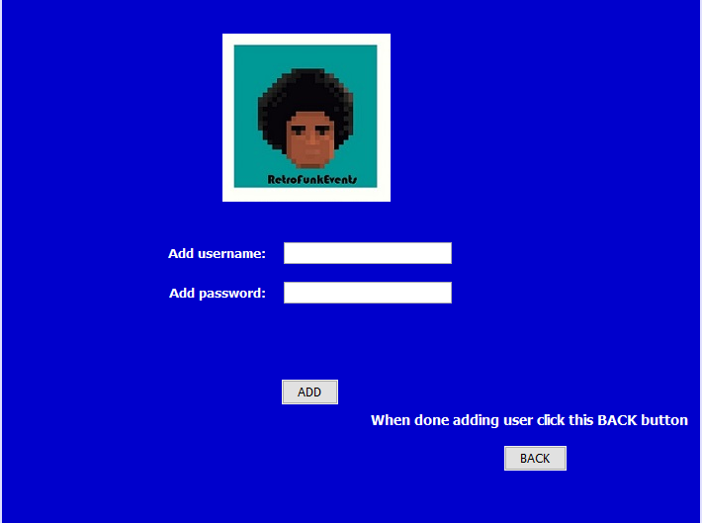(Add user panel)

Add username: this textField is where you enter your new username (can be made up)

Add password: this textField is where you enter your new password (can be made up)

Add button: once done adding your new username and password press the add button, this will add all your information in the textFile where all the usernames and passwords are stored

Back button: after pressing the add button you click the back button. This will take you to the login screen again where you can login with your mad up username and password

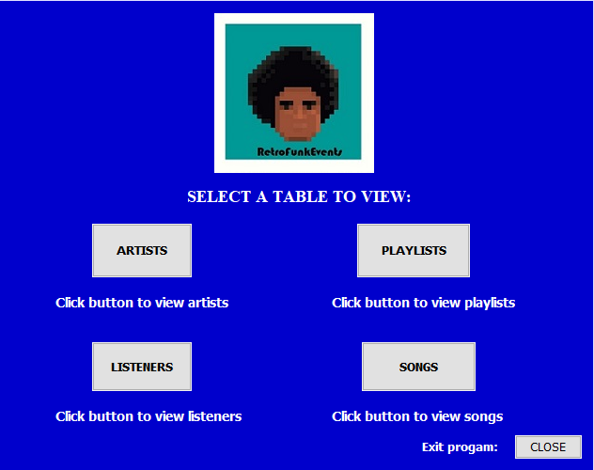(Main Menu Panel)

This is the main menu panel where you will be asked to choose a button to view a table of your choice

Artists button: when you click this button, you be taken to another panel so that you can view the artist table and all the content in it (tblArtists)

Playlists button: when you click this button, you be taken to another panel so that you can view the playlist table and all the content in it (tblPlaylists)

Listeners button: when you click this button, you be taken to another panel so that you can view the listener table and all the content in it (tblListeners)

Songs button: when you click this button, you be taken to another panel so that you can view the song table and all the content in it (tblSongs)

Close button: this button will allow you to exit the program

Tables on display (tblArtists/tblListeners/tblSongs/tblPlaylists)

When you clicked a button from the previous page to view a table you now have access to view whatever tables you want to view

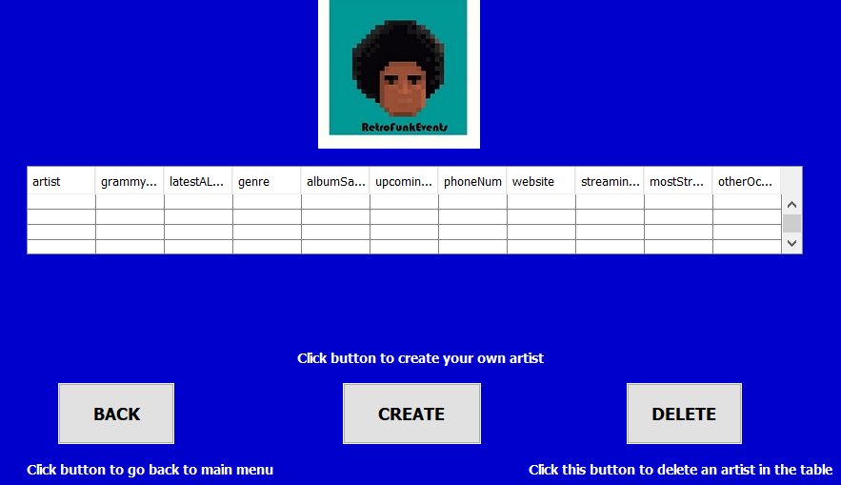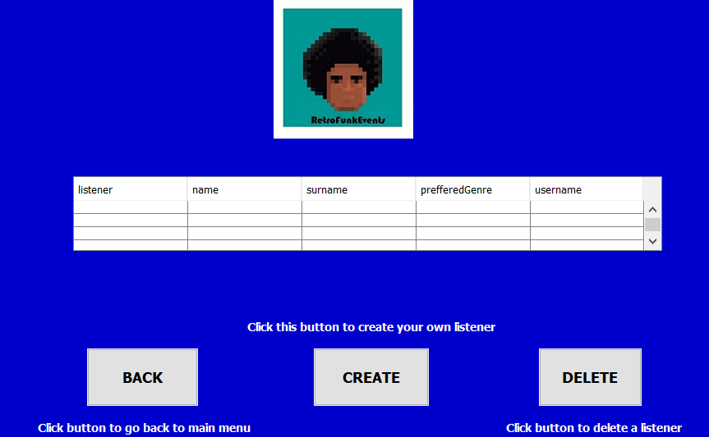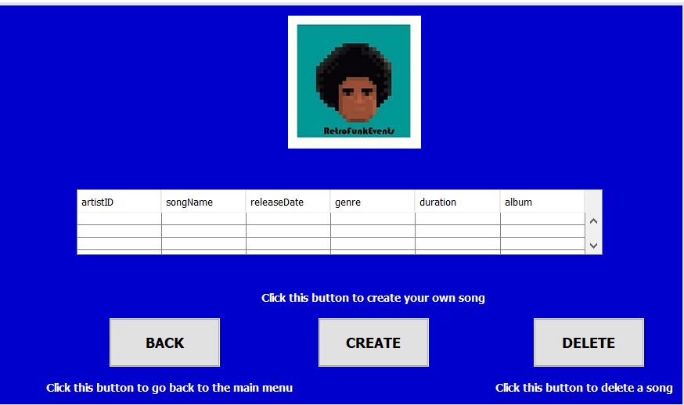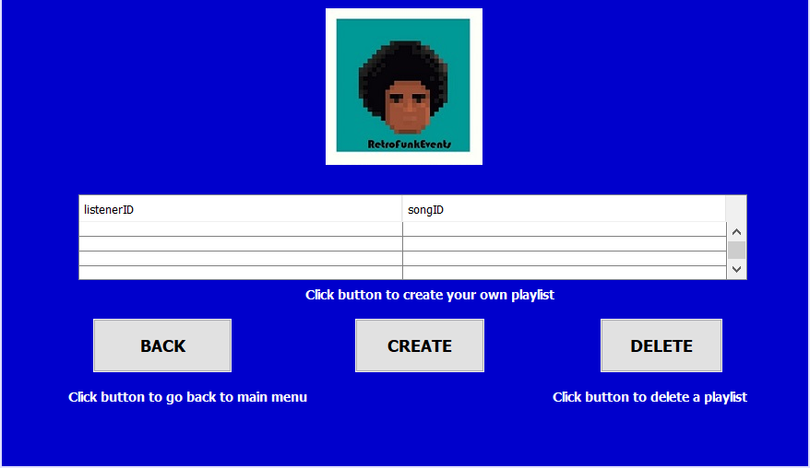

When you clicked on a button in the main menu to view a table of your choice the GUI took you to that panel. You now are viewing a table of your choice with 3 buttons below the table. To edit a table and enter your own values you can click directly on the table and change whatever variables you want

Back button: when this button is clicked it’ll take you back to the main menu so that you can select another table

Create button: when this button is clicked on any of these 4 tables you’ll be taken to another screen (panel) where you’ll be able to create your own object (whether it be a song or artists or playlist or listener)

Delete button: when this button is clicked, you’ll be able to delete an object of your choice by clicking on the row and when the row is selected click the delete button. The row in the table will be deleted

Search button (these buttons were added after the screenshots): this button will allow user to change the panel they are currently on and go to a panel where they can search for an object they want to search for

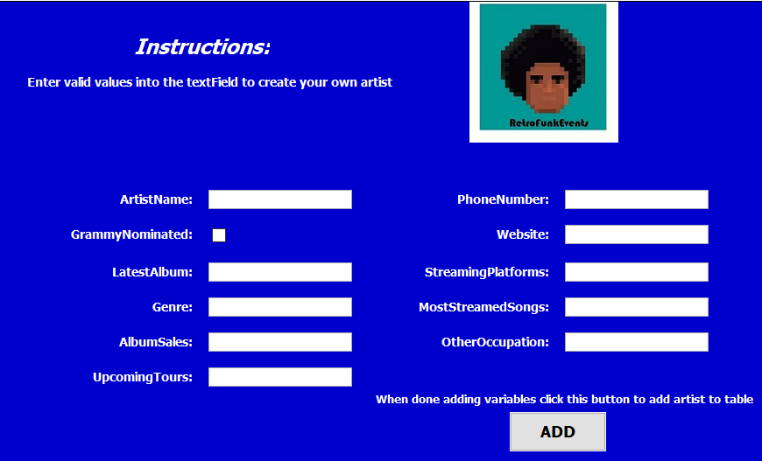(Add artist/listener/playlist/song GUIs)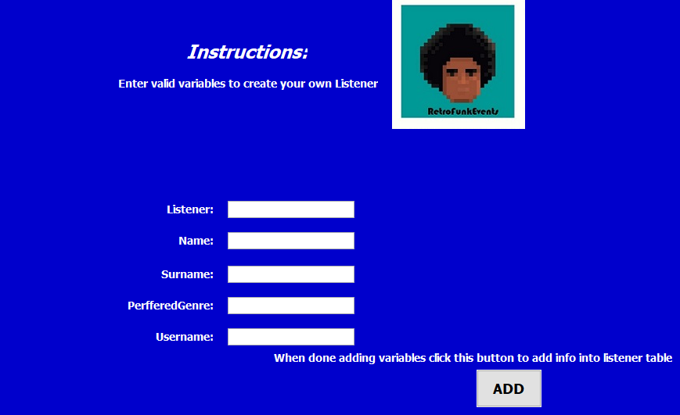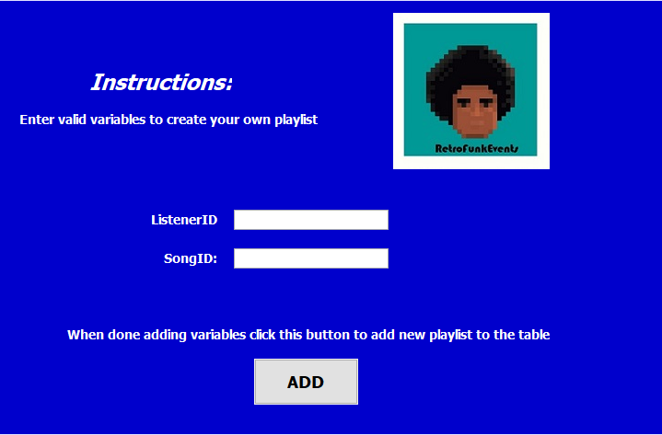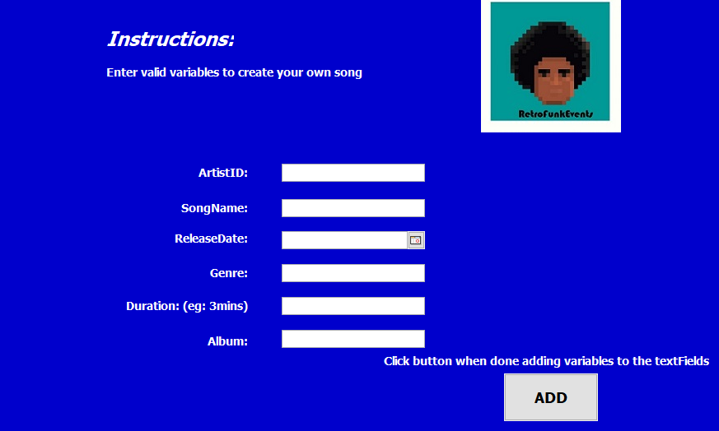

In these pages/panels you are able to create your own objects (artist/listener/playlist/song). You do his by entered values or your choice into the textFields. Once you’ve filled in all the required spaces (blanks) click the add button

Add button: what this button does is it takes all the variables you’ve entered in the spaces and used them to create an object (whether it be a song or playlist or listener or artist). Once this is done you will automatically be taken back the page you were previously on (the table you clicked ‘ADD’)

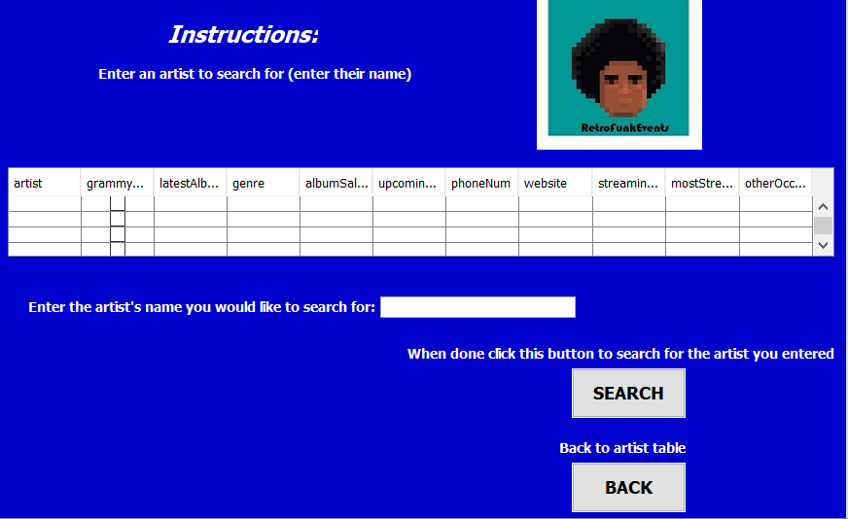(Search panel/pages)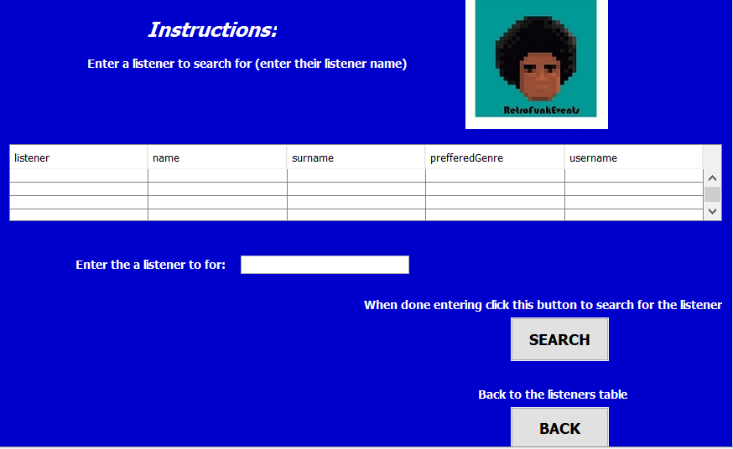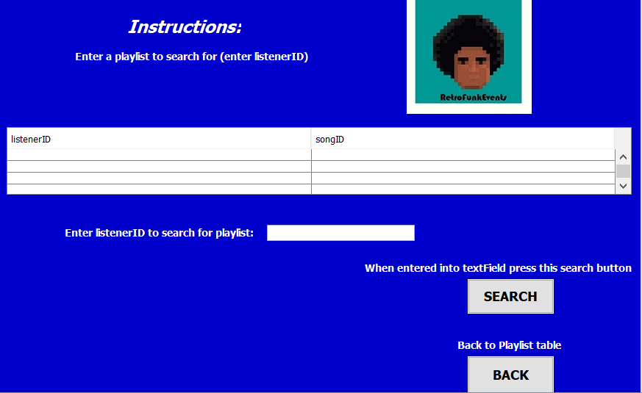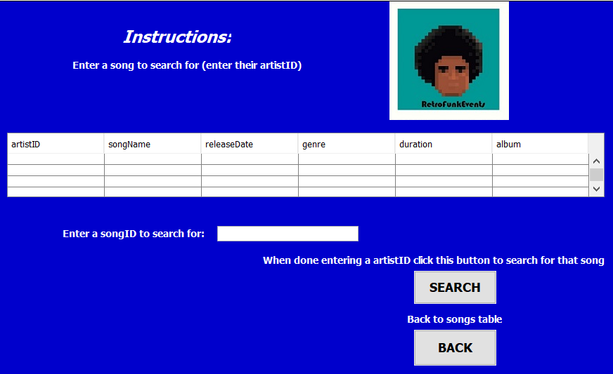

These panels are do the same purpose but for different objects. These panels give you the ability to search for an variable you like (whether it be a song/listener/playlist/artist)

What you do is simple, enter a variable to search for in the textField and when you’ve done that press the search button on the screen so that the value you entered will be searched for. You’ll get a message on the screen if the value you’ve entered was found or not. It’s up to you afterwards when you’re done to go back to the previous table you were on using the Back button the view the table again